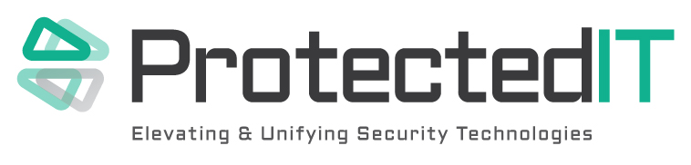
Certified RSA Netwitness Engineer
What can you expect when you are a ProtectedIT Consultant?
* To be treated with respect and integrity * To work with cutting edge technology * To deliver high-quality solutions across multiple industries * To work on a variety of projects ranging in both size and scope * To engage in fast paced, exciting environments.
Our consultants assist companies with the identification, evaluation of security threats and the subsequent delivery of solutions to remediate these threats. They also anticipate security requirements and identify sound security controls for applications, systems, processes and organizations. We are currently searching for consultants with prior experience and working knowledge of eDiscovery, malware analysis, Data Forensics, risk mitigation, threat management, incident management and vulnerability assessments.
Key Responsibilities may include: * Evaluating threats, vulnerabilities and risk while supporting real-time security monitoring operations * Build, implement and deploy data security solutions * Communicate with all levels of clients, follow methodologies, and create/present clear, concise deliverables * Expertise with tools and processes used in security incident detection and handling * Security event analysis and intrusion detection (IDS/IPS Incident response - triage, incident analysis, remediation) * Ability to perform deep forensic analysis to aid in finding threats/suspicious activities in the enterprise * Security Operations Center Procedures and Processes * Experience with next generation threat defence technologies such as NetWitness, Solera Networks and/or FireEye * Develop processes and procedures around malware detection and analysis
Basic Qualifications: * Minimum 4 years of information security experience * Prefer experience with RSA NetWitness
Professional Skill Requirements:* * Eagerness to contribute in a team-oriented environment * Ability to work creatively and analytically in a problem-solving environment * Desire to work in an information systems environment * Excellent communication (written and oral) and interpersonal skills * Strongly prefer industry-adopted security certifications such as CISSP, CISA, CISM, SANS, GIAC Certified Incident Handler (GCIH), GIAC Certified Intrusion Analyst (GCIA)
Required Certificates: RSA NetWitness Logs and Network Certified Administrator and RSA NetWitness Endpoint Certified Administrator
Please apply directly on our Web site via the Careers form.

